Lesson plan 1: Drop-down lists, VLOOKUP and sorting data
About the lesson
This lesson introduces students to a range of tools that can be used to develop more sophisticated spreadsheets. They will learn how to create drop-down lists, so that users can choose from a list of items, and how to use the VLOOKUP function to return a value based on the contents of a cell. They will also learn how to sort data in a table. They will then apply this learning to practical activities using the spreadsheets provided.
Learning objectives
By the end of this lesson, students will be able to:
- create and use drop-down lists to validate data entry
- write VLOOKUP functions to find data in a table and return related information
- sort data in a spreadsheet.
National Curriculum
The following subject content from the KS3 National Curriculum is included in this lesson:
- Design, use and evaluate computational abstractions that model the state and behaviour of real-world problems and physical systems
- Understand the hardware and software components that make up computer systems
Links
Spreadsheets are a tool used to collect and analyse data in a range of subjects across the curriculum, including maths, the sciences and geography. The skills learned through completing this unit should equip students with the skills to use spreadsheets effectively in any other subject.
Key terminology
drop-down list, validation, VLOOKUP, sort
Teaching and learning activities
Share the objectives for the lesson with students (Slide 2 of Lesson 1 presentation).
Starter
Show students an image of a spreadsheet (Slide 3).
Ask: Tell me about one thing you know how to do on a spreadsheet.
Students should come up with a range of answers including: write formulae to perform calculations; use functions such as SUM,IF and COUNT; format cells to change their appearance or to set them as currency; use relative and absolute cell references.
Summarise students’ prior knowledge and check their understanding by asking them to explain each feature listed on the slide to one another (Slide 4).
This slide assumes that students have previously completed Introducing spreadsheets and you may want to edit it if you are teaching this module without first teaching Introducing spreadsheets.
Part 1
Ask: Can anyone explain to me what validation is?
It is checking the accuracy of something.
Explain that, in a computer program, you might use validation to check that a number entered by a user is between 1 and 100, or that an email address includes the @ sign. Validation can also be added to spreadsheets to help to reduce errors caused by users entering inappropriate values. One way of doing this is to create a drop-down list so the user selects the value they want from a predefined list (Slide 5 and page 78).
Demonstrate how to create a drop-down list (Slide 6 and page 78, plus Video 1.1 (Excel) and Video 1.1 (Google Sheets)).
Ask students to complete Activity 1.1: Stationery shop (Part 1) (Slide 7, Excel workbook 1, sheet 1/Excel workbook 1.1; Google Sheets workbook 1, sheet 1/Google Sheets workbook 1.1).
Example answer
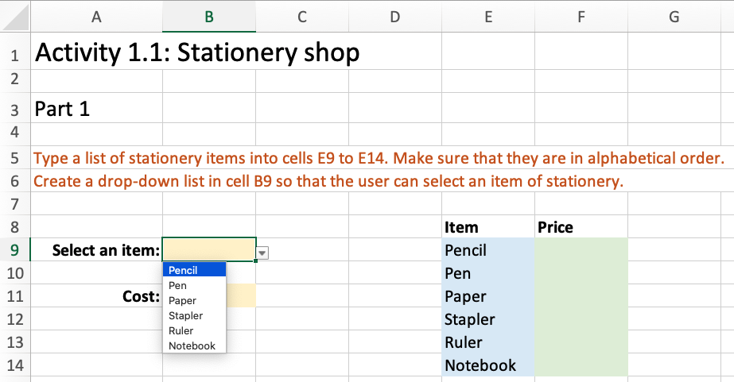
Part 2
Explain how the VLOOKUP function works (Slide 8 and page 78).
Demonstrate how to write a VLOOKUP function (Slide 9 and page 78, plus Video 1.2).
Ask students to complete Activity 1.1: Stationery shop (Part 2) (Excel workbook 1, sheet 1/Excel workbook 1.1; Google Sheets workbook 1, sheet 1/Google Sheets workbook 1.1).
Common misconceptions
Often students do not appreciate that the items must be in order (alphabetical or numerical) for a VLOOKUP function to work correctly. If necessary, they will need to re-create their drop-down list to ensure that the correct values are returned when using VLOOKUP.
Check the function in cell C11 is:=VLOOKUP( B9, $E$9:$F$14, 2)
Ask students to complete Activity 1.2: Exam grades (Excel workbook 1, sheet 2/Excel workbook 1.2; Google Sheets workbook 1, sheet 2/Google Sheets workbook 1.2).
This activity asks students to use the IF function, which is covered in the Introducing Spreadsheets module.
Answer
- Make sure that the correct function has been entered into cell C8: =VLOOKUP( B8, $F$8:$G$12, 2 ). Check that this has been replicated to cells C9 to C12.
- Make sure the correct function has been entered into cell D9 and this has been replicated to cells D9 to D12: =IF( B9 >= 60, "Pass", "Fail" ). Make sure that the correct logical test is used and the text to be displayed is enclosed in double quotation marks. Pass should be displayed if the condition is True and Fail should be displayed if the condition is False.
Part 3
Explain and demonstrate how to sort data in a table into alphabetical or numerical order (Slide 12 and page 79, plus Video 1.3 (Excel) and Video 1.3 (Google Sheets)).
Ask students to complete Activity 1.3: Countries and capital cities (Excel workbook 1, sheet 3/Excel workbook 1.3; Google Sheets workbook 1, sheet 3/Google Sheets workbook 1.3).
Common misconceptions
A common misconception when sorting data is that only the column to be sorted should be selected. However, this will result in adjacent columns in the row containing the incorrect data. All of the data should be selected so that the data in each row remains consistent.
Answer
- Make sure that the drop-down list in B7 includes all the values in the range A13:A212
- Check that the correct function has been entered into cell B9: =VLOOKUP( B7, A13:B212, 2 )
Ask students to complete Activity 1.4: Cars (Excel workbook 1, sheet 4/Excel workbook 1.4; Google Sheets workbook 1, sheet 4/Google Sheets workbook 1.4).
Answer
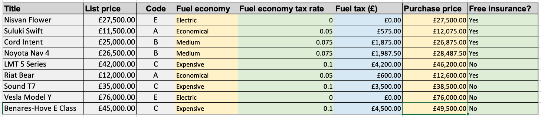
- Make sure that the relevant cells in columns B, F and G have been formatted as currency.
- Check that the correct function has been used in D16 and replicated:
=VLOOKUP( C16, $A$28:$B$31, 2 )
- Make sure that the values in A35:B38 have been sorted so that the fuel economies are in alphabetical order.
- Check that the correct function has been used in E16 and replicated:
=VLOOKUP( D16, $A$35:$B$38, 2 )
- Check that the correct formula has been used in F16 and replicated: =B16*E16
- Check that the correct formula has been used in G16 and replicated: =B16+F16
- Check that the correct formula has been used in H16 and replicated:
=IF( G16<30000, "Yes", "No" )
Plenary
Check students’ knowledge and understanding with a short question and answer session linked to the learning objectives for the lesson.
- How can we limit the values that a user can enter in a cell on a spreadsheet?
(Example answer: We can use a drop-down list.)
- Why do we use validation in programs and on spreadsheets?
(Example answer: To help eliminate input errors.)
- What does the VLOOKUP function enable you to do?
(Example answer: Find the value of a cell in a table and return the data in an adjacent cell.)
- How can we get a list of data into alphabetical or numerical order?
(Example answer: We can use the sort facility.)
Homework
Ask students to complete work they did not finish during the lesson.
Ask students to complete Quiz 1.

Stretch activities
Some students will complete the activities in this lesson quickly. They could be encouraged to investigate other forms of validation that can be applied to cells, for example that the value must be a whole number and within a fixed range. They should also look at how input messages and error alert messages can be included to help the user enter an appropriate value.
Support activities
Students who struggle to enter the correct cell references when writing the VLOOKUP function should be encouraged to click in the formula bar above the main spreadsheet to highlight the cells that are being used. This will enable them to check that their references are correct. They should be reminded to use an absolute cell reference when replicating the function to other cells.
Encourage students to click on the required cell, or cells, when entering formulae to avoid simple typing errors.
A number of short and informative videos can be found online that demonstrate the use of features in spreadsheets, such as: https://www.youtube.com/c/microsoft365/playlists?view=50&sort=dd&shelf_id=5 for Excel, and https://www.youtube.com/channel/UCco3PQfioWg5uFBxi1ndb2A for Google Sheets.
Step-by-step instructions for functions in Microsoft Excel can also be found at
https://www.w3schools.com/excel/excel_functions.php

